General Report for the SA8000 System
1/2018
20/03/2018

Content

1. Introductory Note 3
2. Towards Sustainability 3
3. Activities developed 4
➢ Collaborators 4
➢ Health and Safety at Work 5
➢ Environment 5
➢ Supply chain and subcontractors 6
➢ Evaluation Suppliers 7
➢ Social causes 7
➢ Communication with the outside 8
4. Important Frames 2017
5. Conclusion 9

1. Introductory Note
This document is the Scoop - Scorecode Texteis SA Social Responsibility Report within the framework of SA 8000 standards.
This document is issued as a way to disclose the overall performance of our system for the year 2014.
2. Towards Sustainability
Based in Portugal, Scoop - Scorecode Textiles SA has spent the last 25 years building its reputation as a strategic partner in manufacturing garments for some of the world 's largest brands and has been recognized for its core competencies in the sportswear market. In response to market volatility and ongoing challenges in the industry, the company has made strong and deliberate leadership decisions on the quest for responsible manufacturing and is proud of its strong focus on ethical and sustainable supply chain management. Scoop - Scorecode Texteis SA, is a purpose oriented company, with robust practices of transparency and innovation, and follows the spirit of "acting locally, thinking globally". With a dynamic business atmosphere, it cultivates versatility by seeking ways to positively impact our environment and its employees, partners and community by following SA 8000 social certification standards.
The company strongly believes in acting positively to reduce its environmental impact and has steadily intensified its responsibility efforts in recent years, moving towards an additional certification in environmental liability (ISO14001).
Recently a member of the United Nations Global Compact, it is part of a universal language for corporate responsibility, and follows guidance at every step of the way, committing to assess, define, implement, measure and communicate a sustainability strategy.
3. Activities developed
- Employees
In March 2018 the reality of collaborators was:
% Employees Men 12.61%
% Employees Women 87.39%
No. of Employees 119

The company has a particular responsibility to our employees. We recognize the importance of our employees being motivated, happy, committed.
Obtaining a positive feedback contributes to knowing the aspects improve to increase the level of satisfaction of our work team.
In the year 2017 the satisfaction rate obtained from our employees was 83%.
We are open to suggestions and complaints from our employees during the year 2017 we received 4 suggestions, one of which was anonymous and the others were equally awarded.
- Health and Safety at work
The company ensures compliance with the safety, health, hygiene and welfare standards in the workplace, through a safety team that periodically inspects the protection and prevention equipment.
All employees are regularly trained in this field (extinguisher and first aid handling).
Compliance with safety rules is an obligation of all, and it is the duty of employees to inform the security officer in a timely manner of any irregular situation that may compromise the safety of persons, facilities or equipment of your company.

Environment
The generation of waste is an inevitable phenomenon that occurs in our industry daily in volumes and compositions that vary according to our segment of performance and productive level.
The company favors the reduction of production at source, the reuse and recovery of waste generated, thus contributing to the saving of natural resources, for the reduction of waste sent to final disposal (landfill).

The solid urban waste generated is sent to the respective Municipal Service.
- Supply chain and subcontractors
In order for all those who work with us to feel involved in matters of Social Responsibility we have developed the Supplier Kit, which includes the term of commitment and certification of the term of commitment, policy, Values ​​and principles among others.
Number of Approved Suppliers 2017: 98
During 2018 the team went to the facilities of 19 of our suppliers and subcontractors, to know their space and working conditions, but above all to share the principles of Social Responsibility.

Evaluation of Suppliers
The relationship with suppliers continues to be one of the great pillars for the success of the company, and its evaluation process is a tool for managing the relationship between the organization and this stakeholder.
The supplier evaluation process is a transverse monitoring mechanism of adherence to the requirements and specifications provided in the services provided and supplied goods, procurement procedures, internal procedures for quality, environment, hygiene and safety at work and social responsibility established in the organization.
Thus, by evaluating the performance of its suppliers, it is allowing them to evolve and respond to the required degree of demand. In order to streamline the results of the evaluation of suppliers and in order to detect situations that can be improved with the partners in a timely manner, the periodicity of the evaluation is annual
- Social causes
The company has embraced a set of social causes with the goal of providing greater well-being to society and our community.
Whenever possible the company makes donations of products for projects developed by non-profit organizations, preferably based in the council of Vila Nova de Famalicão.
The company encourages employees to donate blood by informing them through internal communication channels, and by promoting blood collection actions within the facility through IPS.
- Communication with the outside and activities
The company is based on transparency in all its area of ​​activity, as well as with all those who interact directly / indirectly.
The company chooses ways to advertise positive models and healthy habits.
Through our website we let our partners know about organizational performance and practices.
BRING YOUR CHILDREN TO WORK
It gives the possibility to the children of our collaborators to know the place of work of the parents, during that day several educational activities are developed
BANK OF THE SCHOOL BOOK
With the end of the school year, we have sensitized our employees to bring books that can be used by others. This action takes place in September.
SUPPORT LEAGUE AGAINST CANCER MAMA
Month of October is the month all together to support this cause that is everyone's.

Achievements 2017

Assumed Compromises:

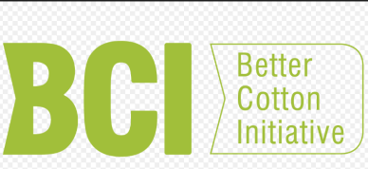
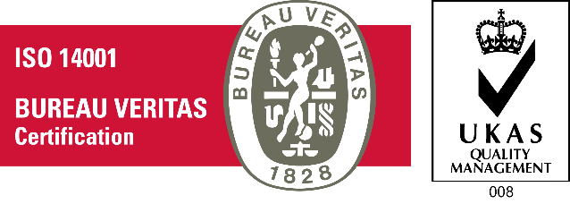

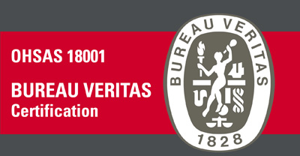
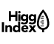

Conclusion
The emerging socioeconomic relationship and the information society require new competitive factors to the market. In this context, SCOOP - SCORECODE TEXTEIS SA is aware that it can contribute to sustainable development by managing its operations in order to consolidate economic growth and increase competitiveness, while ensuring environmental protection and promoting behavior ethically and socially responsible.
We have adopted a policy of social responsibility, which is an important part of the road to sustainability. Demonstrating in a transparent way our modernity, creativity and, above all, our commitment to the stakeholders.

